**如何营造故事场景高潮**

What is a climax of a story?（什么是故事高潮?）

More tension=satisfying climax

文学故事中的高潮（climax）----故事的主要场景（key scene）也通常是故事的转折点（turning point），是指故事达到最紧张或扣人心弦的那一部分。高潮有时候是剧情中的 "危机" 点。有时候, 它只是达到关键时刻或者转折点, 发生了一些事情, 或者主角必须做出决定, 从而导致一个结果或其他。我们在分析叙事类故事或者小说故事的时候常常用下面的图表来表示故事情节。

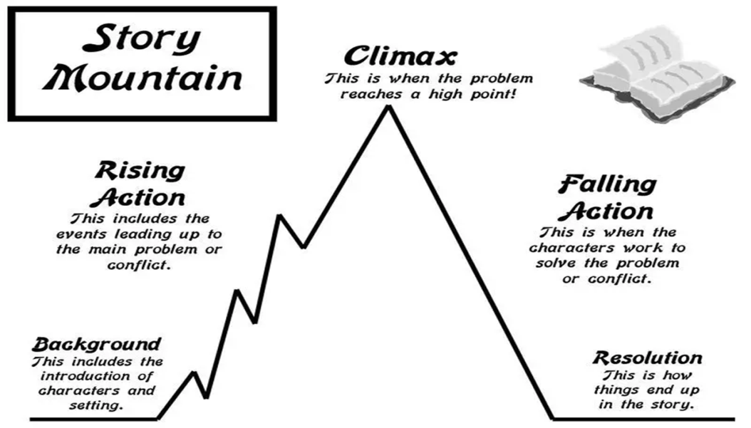

**常见故事高潮示例：**

1. A little girl has been searching for her lost dog. All of a sudden, she hears a bark coming from around the corner, and she looks around to see . . .  
2. Kevin has worked very hard to try out for the soccer team at school. The coach has posted a list of this year's team members on his office door. Kevin walks forward to look at the list . . . .  
3. Mary's parents have been discussing whether or not to move to another state. They call Mary and her sister down to talk with them about their decision . . .  
4. Lois has performed in the state gymnastics finals. She waits anxiously to hear the names of the winners. The announcer says, "And first place goes to . . ."

文学名著中的一些故事高潮

1. The deaths of Romeo (who kills himself because he thinks Juliet is dead) and Juliet (who kills herself when she awakes and sees Romeo dead). Romeo and Juliet, Shakespeare （罗密欧和朱丽叶，莎士比亚）  
2. When Gaston and the townspeople come to attack the beast, and Belle admits her love for the beast. Beauty and the Beast, Disney （美女与野兽，迪士尼）  
3. In "The Three Little Pigs," suspense builds up until the confrontation between the third pig and the wolf. This confrontation is the climax.（三只小猪）

How to create a climax of a story?  (如何营造故事的高潮？)

**方法1.增加外部冲突**

增加外部冲突是一种明显有效的可以达到故事高潮的方式。冲突带来紧迫感, 将故事推向必要的解决或崩溃。

**1）角色之间的冲突** (人物观点差异, 竞争需要等)

如：**2017年11月浙江英语高考：**On the fourth or fifth night, we had trouble finding a hotel with a vacancy. After driving in vain for some time, Mom suddenly got a great idea: Why didn't we find a house with a likely-looking backyard and ask if we could set up tent there? David and I became nervous. 开车找旅馆---徒劳无功---母亲建议搭帐篷在他人后院---David和我倍感紧张，心有不悦（母子的观点不一）

**2) 角色与环境之间的冲突**

如：**2017年6月浙江英语高考：** Then Mac heard quick and loud breathing behind him. ……he saw instantly that it wasn't a dog at all, but a wolf: quickly catching up with him. Mac's heart jumped. ……, he fired the spray at the wolf. A bright red cloud enveloped the animal, and to Mac's relief, it fell back, shaking its head. But a minute later, ……. Then it ……, tearing open his tent bag. He fired at the wolf a second time, and again, it fell back ……

Mac骑车独自行，路遇饿狼，与之搏斗，险象环生。（人（角色）----狼（环境）大战）

**3) 时间依赖的发展** ：决策变得紧急

如：**2017年6月浙江英语高考：**The car abruptly stopped in front of him. "Get into the car." Paul shouted at Mac. Mac jumped off the bike and slid into the car without delay as the wolf was just two steps away and was about to tear Mac into pieces. What a narrow escape! 骑车突停面前---急喊上车---Max上车避险---饿狼近在咫尺（此情此景，刻不容缓）

**4) 增加的障碍**：人物角色必须克服 挑战, 以达到他们的目标

例如：**2018年6月高考**But before we jumped off the horses, we found that we had been off the beaten track and got lost. We had no idea where we were and it got dark. Exhausted and hungry, I wondered if we could find our way back.  小兔突现---马儿受惊---草原迷路（障碍1）----天色渐黑（障碍2）----又累又饿（障碍3）----心理恐慌（障碍4）

**方法2. 放大内心冲突**

放大内心冲突（你的角色的内心斗争）也有助于建立一个高度紧张和不确定的时刻。

现在我们在来看高考读后续写中的内心冲突是如何体现的：

**2016年10月浙江高考：** Immediately, an absolute darkness ruled the forest. Jane, exhausted and scared, lay down near a stone, missing her family at a distance. All the fantastic memory crowded in and she couldn't help crying, **"Hadn't I quarrelled with Tom, walked away and climbed to the high place, I wouldn't be trapped in this awful place, confronted with the danger of dying.”** She regretted with endless anxiety, and then became asleep with shining tears in her eyes.

夫妇争吵---独自行走---荒野走散---夜色渐黑---独处森林---阴森恐怖---后悔莫及（内心冲突的刻画）内心独白**（往昔对比+虚拟语气使用+旁边描写是常见技巧之一）**

**方法3. 使用环境描写增加不确定性**

充分利用环境描写可以起到烘托故事高潮的作用，具体方法可以看上期读后续写微技能。当故事角色在碰到困难时候，我们往往要加大笔墨来描写故事环境的黑暗，恐怖和不祥。强化环境描写增强了高潮元素。我们感受到了紧张的倍增。

例1：Immediately, an absolute darkness ruled the forest(黑暗). Even worse, the temperature suddenly dropped dramatically. (寒冷）

例2：It didn’t take long for the forest to be enveloped in darkness（黑暗）. Her rasping breath steamed（寒冷） in the moonlight and her throat was parched from thirst.

如何通过场景营造（mood）

**Technique 1: Personification (拟人)**

**Description/purpose:**

Gives an object the characteristics of a living thing, bringing it to life

**Examples：**

The flowers nodded.

Snowflakes danced.

Thunder grumbled.

Fog crept in.

The wind howled.

The haunted house seemed to stare at me, beckoning me towards the door.

**Technique 2: simile (明喻)**

**Description/purpose:**

**Similes** likens something to something else giving a more detailed description

**Examples：**

The night sky was as dark as the deepest ocean.

The stars sparkled like diamonds.

The snake moved like a ripple on a pond.

**Technique 3: metaphor (暗喻)**

**Description/purpose:**

Metaphors say that something is something else, giving the description more power

**Examples：**

A wave of terror washed over him.

**Technique 4:Vivid adjectives (生动的形容词)**

**Description/purpose:**

To make the story more interesting and vivid by using more imaginative descriptions, sometimes in a list

**Examples：**

Gleaming, glistening, whispery flakes of snow

**Technique 5: Negative description (否定描述)**

**Description/purpose:**

To tell the reader what is not there is an effective way of showing how unpleasant, comfortless a place is

**Examples：**

There was no cushion, no carpet, no warmth, no light and no comfort.

**Technique 6: Camera-pan and zoom (摄影-全景+放大)**

**Description/purpose:**

To use the idea of how a film director works, you can give a wider view then focus in on one detail

**Examples：**

From the withering trees he looked past the littered farmyard, across to the decrepit hovel. Its doors hung sadly awry, the handle broken.

**Technique 7: Nouns for details (细节名词)**

**Description/purpose:**

Scenes are filled with things that we see and therefore uses lots of nouns, even lists of nouns to convey what is there.

**Examples：**

The rooms were crowded with lanterns fastened on oak paneled walls, tables laid with silver candlesticks and goblets.

**Technique 8: Senses（感官）**

**Description/purpose:**

All of our senses become aware in a new situation or place. Your reader needs to know how your character are feeling.

**Examples：**

Wafts of salt-laden air were in her nostrils as the skittery sand on her feet led her to the edge of the waves.

**Good setting description for appreciation (佳“景”赏析)**

1. The house smelled musty and damp, and a little sweet, as if it were haunted by the ghosts of long-dead cookies.   
2. The sun kept dipping down into the ocean and the lights came on at the harbor, casting sudden shadows on the ground, illuminating the faces that were just a second ago silhouettes. The sky was golden and purple, the ocean a darker shade of violet.   
3. The sun had set, but a faint pastel haze lingered in the mid-summer sky.  
4. They rolled up the path, tree branches raking the windshield like angry wardens.  
5. Outside, the air filled with cricket noise, as the sun reddened in its descent.  
6. A restaurant overlooking a starlit night sprang to my imagination like something out of an illuminated manuscript from the late Middle Ages.  
7. The moon went slowly down in loveliness; she departed into the depth of the horizon, and long veil-like shadows crept up the sky through which the stars appeared.   
8. All brightness was gone, leaving nothing. We stepped out of the tent onto nothing. Sledge and tent were there, Estraven stood beside me, but neither he nor I cast any shadow. There was dull light all around, everywhere. When we walked on the crisp snow no shadow showed the footprint. We left no track. Sledge, tent, himself, myself: nothing else at all. No sun, no sky, no horizon, no world.  
9. Night had fallen fast upon the land. No more than an hour ago the sky was painted with hues of red, orange and pink, but all colour had faded leaving only a matt black canvas with no stars to be looked upon.   
10．It would be a cold moonless night. The sky was dark and low, the air so chilled it hurt to breathe. Already the ground was laid white with frost and any water that had been liquid under the winter sun had become ice.

**如何写好读后续写的开头**

**1. An adverb**  
Carefully, he stepped over all the broken glass.  
Joyfully he skipped up the street.  
Para 1： (201610浙江高考读后续写范文摘录)Para1：But no more helicopters came and it was getting dark again. Immediately, an absolute darkness ruled the forest. （时间副词衔接+环境描写）  
**2. An adj. phrase**  
Curious to know what was inside, he tiptoed into the dark cave.  
Unable to say a word, he was rooted to the spot.  
 (201610浙江高考读后续写范文摘录)Para 1: But no more helicopters came and it was getting dark again. Desperate and hopeless, Jane knelt down, tears streaming down her face. （并列情绪形容词）  
 (201610浙江高考读后续写范文摘录)Para 2: It was daybreak when Jane woke up. Weak as she was, she struggled to her feet, continuing searching for assistance. （状态形容词+as/though 引导的倒装句）  
(201806浙江高考读后续写范文摘录)Para 1:  Suddenly a little rabbit jumped out in front of my horse. Afraid that I might hurt the lovely small creature, I automatically let out a cry to stop my horse. (情绪形容词+从句)  
(201806浙江高考读后续写范文摘录)Para 2: We had no idea where we were and it got dark. Exhausted and hungry, I wondered if we could find our way back.   
**3. A participle (-ing or –ed word)**  
Looking around him cautiously, he slipped into the room and softly closed the door.  
Exhausted, he was glad the race was finally over.  
(201610浙江高考读后续写范文摘录) Para1: But no more helicopters came and it was getting dark again. Feeling disappointed, Jane had to stay alone for another night. （现在分词+情绪形容词）  
(201610浙江高考读后续写范文摘录) Para 2: It was daybreak when Jane woke up. Feeling refreshed, she continued to walk along the stream to find the way out.（现在分词+状态形容词）  
**4. A conjunction**

**As he walked**, he whistled  
**Although he was afraid**, he jumped right in.  
**5. A prepositional phrase**  
**At the end of the lane** he suddenly stopped.  
**At the sight of the snake**, the little girl screamed at the top of her voice.  
**6. A dialogue or a monologue**  
**“Let’s see who gets there first!”** Rachel shouted, as she pedaled fast and zoomed past Jenny.  
**“Hold on tight!”** My father yelled. We just finished bucking in as the coaster jerked into motion. This was my first roller coaster ride.  
(201706浙江高考读后续写范文摘录)Para 1: The car abruptly stopped in front of him. **"Get into the car." Paul shouted at Mac.**  
**7.  A character**  
**Mark is a studious boy who loves reading. His classmates often tease him for being too hardworking and they call him Mr. Smart.** One afternoon, while studying at home…

**8.  An emotion**  
The moment she saw how she did for her Science test, **tears started welling up in Tina’s eyes and falling down her cheeks.**

**9. A setting**

I **closed my eyes to enjoy the gentle breeze and the sounds of the clashing waves**. **Gently opening my eyes, I saw my parents taking** a relaxing stroll along the beach.

**The cave was dark and everything was silent. I couldn’t even see my hand in front of my face.**I knew this adventure was going to be something that I would never forget.

(201711浙江高考读后续写范文摘录)Para 2: We drove through several states and saw lots of great sights along the way. **I looked out of the car window, winding rivers, lofty mountains, sunny beaches and deep valleys holding me entirely in their fascination. （视觉+环境描写+拟人）**

**10. An action**

Furry **started wagging his tail and running around in circles** when he saw his master taking a leash out from the drawer. Furry was all ready for his evening walk.

(201711浙江高考读后续写范文摘录)Para 1: The next day we remembered the brand-new tent we had brought with us. **Dad exchanged a glance with me. Why not camp to satisfy Mom?  （动作描写+问句衔接）**

**11. Sound effects**

**BOOM, CRASH!**The wind was howling outside of my house. We were having a terrible thunder storm. I was very scared.

**12. A question**

**Have you ever been on a self-driving trip?**Let me tell you an exciting trip my family took this summer.

**Why does trouble always follow me around? Do I have a "kick me" sign on my back or something?**

**其他**

**神态动作描写:**

**David excitedly narrated our experience, eyes blazing with enthusiasm. Worries came to his forehead when he explained the trouble. A smile lifted the corner of his mouth when it came to camping.**